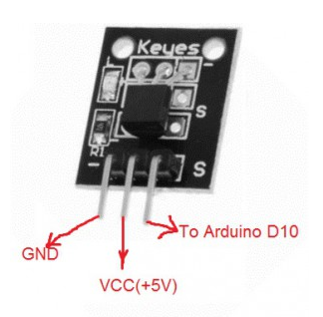

****Step 1:**** connect DS18B20 sensor to Arduino as per following Circuit Connection Graph

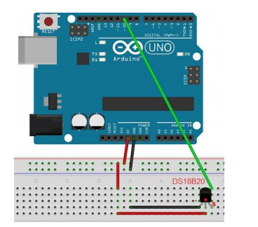

Step 2: Download [OneWire libray](http://osoyoo.com/wp-content/uploads/samplecode/OneWire.zip) and import the zip file into Arduino IDE. If you already have the OneWire Library, skip this step.  
To import library into Arduino IDE, click Sketch ->Import and then select OneWire.zip file from your download folder. See following picture:

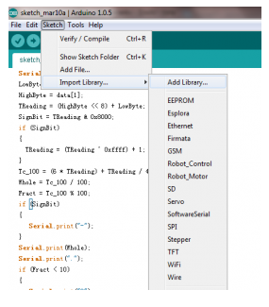

****Step 3:**** Download [DS18B20 sketch code](http://osoyoo.com/wp-content/uploads/samplecode/DS18B20.txt) and load it into Arduino IDE.

****Step 4:****Click the serial monitor window on the upper right corner, you will see temperature results in the monitor window.

